COUNCIL STAFF REPORT
CITY COUNCIL of SALT LAKE CITY

Item Schedule:
Briefing: January 17, 2023
Set Date: January 17, 2023
Public Hearing: February 7, 2023
Potential Action: February 21, 2023

TO: City Council Members
FROM: Brian Fullmer
Policy Analyst

DATE: January 17, 2023
RE: Accessory Dwelling Unit Ordinance Amendment
PLNPCM2022-00475

The Council will be briefed about a proposal to amend the City ordinance related to Accessory Dwelling Units (ADUs) making external units a permitted rather than conditional use, expand locations in the city where they can be built, simplify standards, and encourage their construction.

At its February 9, 2022 meeting, the Planning Commission voted to initiate a petition making ADUs a permitted use in any zoning district where residential units are permitted. This includes ADUs that are internal, attached to a main structure, or in a detached building. Current code only allows ADUs in owner-occupied properties in the City that currently have single family homes (as a conditional use in single-family districts), although internal ADUs are allowed by right due to state code. The Planning Commission expressed a stated desire to expand opportunities for ADUs. City Council and Administrative staff input was also provided resulting in proposed changes summarized in the Additional Information section below.

The Planning Commission reviewed the proposal during its September 14, 2022 meeting and held a public hearing at which three people spoke. Comments focused on making ADUs affordable, support for owner occupancy of the main house, and a suggestion for City funding to assist homeowners to construct ADUs. Concerns cited include removing the conditional use could impact adjacent neighbor privacy, a lack of public comments when ADUs are constructed, and neighborhood impacts from additional on-street parking.

Commissioners discussed increasing the maximum size of a detached ADU from the proposed 720 square feet to 1,000 square feet. A motion was made to forward a positive recommendation to the City Council that includes a modification to increase the maximum size of a detached ADU to 1,000 square feet. That motion passed 6-2. Those voting against the motion were not supportive of the 1,000 square foot maximum.

It should be noted the draft ordinance allows detached ADUs up to 1,200 square feet if the lot size exceeds 12,000 square feet, is outside a residential zoning district, or is part of a planned development that includes a minimum of four dwelling units. In response to a Council Member question, Planning staff clarified there is no minimum space between a detached ADU and the primary residence other than required fire code separation.

The draft ordinance includes a requirement that the owner reside on the property. This requirement may be met by a person related to the property owner or a trustor of a family trust that owns the property living on the property. Exceptions of up to three years are provided for property owners who are on temporary work assignments, serve in the military, are on sabbaticals, or participating in voluntary service. An additional exception is included for property owners who are placed in a hospital, nursing home, assisted living facility or other similar facility that provides medical care.

Goal of the briefing: Review the proposed zoning and future land use map amendments, determine if the Council supports moving forward with the proposal.

POLICY QUESTIONS
- The Council may wish to discuss maximum ADU square footage of 720 square feet, 1,000 square feet, or larger based on lot size.
- The proposed ordinance includes a requirement that the owner reside on the property as noted above. The Council may wish to discuss whether to keep this requirement.
- The Council may wish to discuss incentive options for homeowners constructing ADUs to be rented at affordable rates, and potential sources of that funding.
  - The Council, acting as the RDA board, allocated funding in the 9 line project area to assist in funding construction of ADUs, although this funding was limited to that project area.
  - The Council has also directed funds from “Funding Our Future” sales tax revenue towards incentivizing development of affordable housing units and programs.
ADDITIONAL INFORMATION
As previously noted, there are several proposed changes to the ADU ordinance. These are summarized below. For the complete analysis, please see pages 2-10 of the Planning Commission staff report.

Remove Conditional Use Requirement
ADUs are currently permitted in two-family and multi-family zoning districts by-right when associated with a single-family dwelling. Detached ADUs in a single-family residential district are required to go through the conditional use process. It is worth noting House Bill 82 went into effect in October 2021 making internal ADUs permitted uses in single-family residential zones. The proposed ordinance aligns with that legislation.

The proposal removes a conditional use requirement for detached ADUs in single-family residential districts. This would streamline the process for applicants and reduce staff and Planning Commission time needed to review ADU applications. Planning staff noted “Potential negative impacts of ADUs would continue to be managed by the development standards in the ADU Ordinance.”

Expand Where ADUs Can Be Built
One goal of the proposed ADU amendments is to expand where they are allowed. Tables summarizing impacts to zoning districts under the proposed ADU amendments are included on pages 3-4 of the Planning Commission staff report. They are replicated in Attachment A to this report for convenience.

Currently ADUs are allowed as a conditional use on properties used for single-family residential in residential zoning districts. In summary, the proposed changes would allow ADUs as a permitted rather than conditional use in single-family residential zoning districts, allow them as a permitted use in several lower intensity commercial zoning districts, transit station districts, form-based, and downtown zoning districts. ADUs would continue to be prohibited in manufacturing districts, and special purpose districts.

Planning staff included the following maps on page 5 of the Planning Commission staff report showing current locations where ADUs are allowed and where they would be allowed under the proposal. The maps are included here for convenience.

Map showing where ADUs are currently allowed
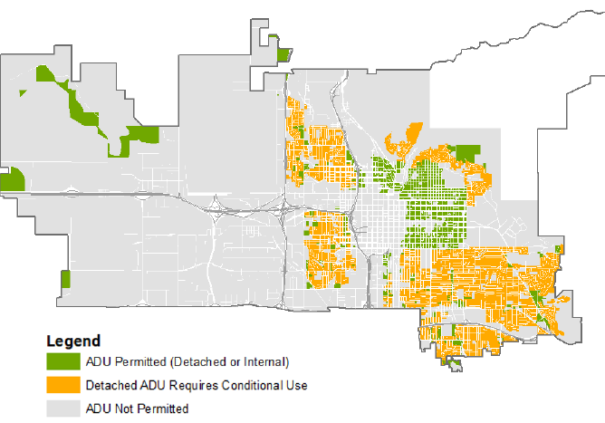

Map showing where ADUs would be allowed under proposed changes
Images Courtesy Salt Lake City Planning Division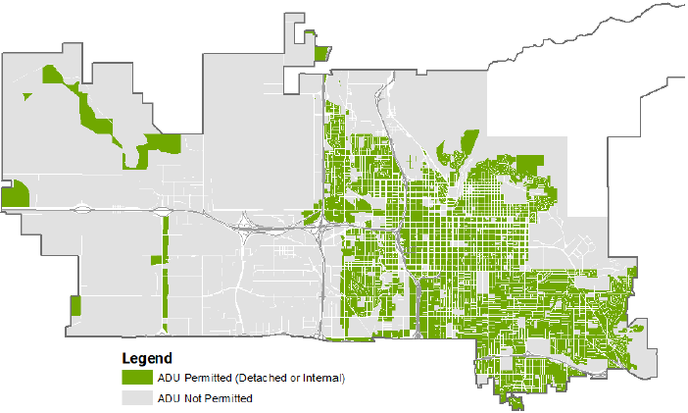

Adjust Size, Bulk, and Yard Requirements
The proposed amendment modifies size, bulk, and yard requirements to generally make them less restrictive. These are summarized in the following tables provided by the Planning Division. (Images depicting various standards are found on pages 7-8 of the Planning Commission staff report.)

Internal ADUs
Standard | Current Requirements | Proposed Requirement
Maximum Size | 50% of gross square footage of principal structure. | No maximum. Aligns with HB82.

Detached ADUs
Standard | Current Requirement | Proposed Requirement
Maximum Size | 50% of principal structure’s footprint or 650 square feet, whichever is less | In residential zoning districts: 720 square feet maximum. Can be increased to 1,200 square feet if lot is 12,000 square feet or larger.
Maximum Height | 17 feet.  If principal structure is taller than 17 feet, ADU can be the same height as the principal structure, up to 24 feet. | 17 feet.  Can be increased up to 24 feet with an increased setback.
Minimum Setback | New accessory buildings and additions to existing accessory buildings: 4 feet from any side or rear lot line.  Second story additions: 10 feet from any side or rear lot line, unless abutting an alley, in which case the setback can be reduced to 4 feet.  If accessory building is taller than 17 feet, setback must be increased to 10 feet, unless abutting an alley, in which case setback can be reduced to 4 feet. | 3 feet from interior side or rear lot lines.  10 feet from corner side lot line.  If accessory building is taller than 17 feet, setback must be increased by 1 foot for every additional foot in height above 17 feet.

Introduce Alley Activation Requirements
Detached ADUs are often constructed adjacent to public alleys, which provides an opportunity to activate the alleys. The proposed amendment adds requirements for ADUs abutting alleys to include lighting on the ADU to illuminate the abutting alley segment, and a path between the ADU and alley.

Keep Short-Term Rental Restrictions
The proposed amendment maintains the current ordinance prohibition on short-term rentals. A definition of “short-term rental” as a dwelling unit offered for rent or lease for less than 3o days would be added.

Adjust Other Requirements
The proposal adjusts and clarifies requirements for decks, patios, and outdoor space. Rooftop patios continue to be prohibited, but balconies are permitted provided they meet setback requirements.

Parking requirements for ADUs would be maintained much as they are if the proposed amendments are adopted. Proposed additions to parking requirements include circumstances under which the required off-street parking stall may be waived. These are:
- The property is in a zoning district with no minimum off-street parking requirement.
- The property already contains at least one accessible stall above the minimum parking requirement.
- The property is within one-half mile of a designated bicycle lane or path.

KEY CONSIDERATION
Planning staff identified one key consideration related to the proposal which is found on pages 10-12 of the Planning Commission staff report and summarized below. For the complete analysis, please see the staff report.

Consideration 1-How the proposal helps implement city goals and policies identified in adopted plans
Planning staff reviewed how the proposed amendments align with goals and policies found in Plan Salt Lake (2015) and Growing SLC: A Five-Year Housing Plan 2018-2022 (2017). They determined the proposal is consistent with several items found in the Growth, Housing, Transportation & Mobility, and Preservation chapters of Plan Salt Lake. Among the initiatives proposed changes align with are the following:
- Locate new development in areas with existing infrastructure and amenities, such as transit and transportation corridors.
- Encourage a mix of land uses.
- Promote infill and redevelopment of underutilized land.
- Accommodate and promote an increase in the city’s population.
- Encourage housing options that accommodate aging in place.
- Enable moderate density increases within existing neighborhoods where appropriate.

Planning also found the proposal is consistent with goals and objectives in Growing SLC. These include:
- Review and modify land-use and zoning regulations to reflect the affordability needs of a growing, pioneering city.
- Develop infill ordinances that promote a diverse housing stock, increase housing options, create redevelopment opportunities, and allow additional units within existing structures, while maintaining neighborhood impacts.
- Revise the Accessory Dwelling Unit ordinance to expand its application and develop measures to promote its use.
- Support diverse and vibrant neighborhoods by aligning land use policies that promote a housing market capable of accommodating residents throughout all stages of life.

ANALYSIS OF STANDARDS
Attachment C (pages 32-34) of the Planning Commission staff report outlines zoning map amendment standards that should be considered as the Council reviews this proposal. The standards and findings are summarized below. Please see the Planning Commission staff report for additional information.

Factor | Finding
Whether a proposed text amendment is consistent with the purposes, goals, objectives, and policies of the city as stated through its various adopted planning documents. | Complies
Whether a proposed map amendment furthers the specific purpose statements of the zoning ordinance. | Complies
Whether a proposed map amendment is consistent with the purposes and provisions of any applicable overlay zoning districts which may impose additional standards. | Proposed regulations would take precedence over overlay zoning districts, except for the Historic Preservation Overlay District. Amendments would be limited by additional standards in this district.
The extent to which a proposed text amendment implements best current, professional practices of urban planning and design. | Complies

PROJECT CHRONOLOGY
- February 9, 2022-Petition initiated by Planning Commission.
- May 12, 2022-Petition assigned to Michael McNamee, Principal Planner.
- May 17, 2022-Application posted for online open house.
- May 18, 2022-Notice mailed to all community councils.
- March 30, 2o22-45-day public comment period for recognized organizations ended.
- September 2, 2022-Planning Commission agenda posted to the website and emailed to the listserv.
- September 8, 2022-Staff report posted to Planning’s website.
- September 14, 2022- Planning Commission meeting and public hearing. Positive recommendation forwarded to the City Council.
- September 29, 2022-Ordinance requested from Attorney’s Office.
- November 28, 2022-Planning received signed ordinance from the Attorney’s Office.
- December 12, 2022-Transmittal received in City Council Office.

ATTACHMENT A:
Proposed Accessory Dwelling Unit Use

Change from Conditional to Permitted Use
in Residential Zoning Districts
Zoning District | District Name
FR-1 | Foothills Estate Residential
FR-2 | Foothills Residential
FR-3 | Foothills Residential
R-1/12,000 | Single-Family Residential
R-1/7,000 | Single-Family Residential
R-1/5,000 | Single-Family Residential

Continue to Be Permitted
Residential Zoning Districts
Zoning District | Name of District
SR-1 & SR-1A | Special Development Pattern Residential
SR-3 | Special Development Pattern Residential
R-2 | Single- and Two-Family Residential
RMF-30 | Low Density Multi-Family Residential
RMF-35 | Moderate Density Multi-Family Residential
RMF-45 | Moderate/High-Density Multi-Family Residential
RMF-75 | High-Density Multi-Family Residential
RB | Residential/Business
R-MU-35 | Residential/Mixed Use
R-MU-45 | Residential/Mixed Use
R-MU | Residential/Mixed Use
RO | Residential/Office

Special Purpose Districts
Zoning District | Name of District
FP | Foothills Protection
AG | Agricultural
AG-2 | Agricultural
AG-5 | Agricultural
AG-20 | Agricultural
MU | Mixed Use

Change From Prohibited to Permitted Use
Commercial Zoning Districts
Zoning District | Name of District
CN | Neighborhood Commercial
SNB | Small Neighborhood Business
CB | Commercial Business
CS | Community Shopping
CC | Corridor Commercial
CSHBD | Sugar House Business District
CG | General Commercial

Transit Station Zoning Districts
Zoning District | Name of District
TSA-UC | Urban Core
TSA-UN | Urban Neighborhood
TSA-MUEC | Mixed Use Employment Center
TSA-SP | Special Purpose

Form-Based Zoning Districts
Zoning District | Name of District
FB-SC | Special Purpose Corridor Core Subdistrict
FB-SE | Special Purpose Corridor Edge Subdistrict
FB-UN1* | Urban Neighborhood
FB-UN2* | Urban Neighborhood
 | *Detached dwelling units currently permitted and will be removed from code

Downtown Zoning Districts
Zoning District | Name of District
D-1 | Central Business District
D-2 | Downtown Support District
D-3 | Downtown Warehouse/Residential District
D-4 | Downtown Secondary Central Business District

Gateway Zoning Districts
Zoning District | Name of District
G-MU | Gateway Mixed-Use

Continue to be Prohibited
Manufacturing Zoning Districts
Zoning District | Name of District
M-1 | Light Manufacturing
M-2 | Heavy Manufacturing

Residential Zoning Districts
Zoning District | Name of District
SR-2 | (Reserved)

Special Purpose Zoning Districts
Zoning District | Name of District
RP | Research Park
BP | Business Park
A | Airport
PL | Public Lands
PL-2 | Public Lands
I | Institutional
UI | Urban Institutional
OS | Open Space
NOS | Natural Open Space
MH | Mobile Home Park
EI | Extractive Industries

