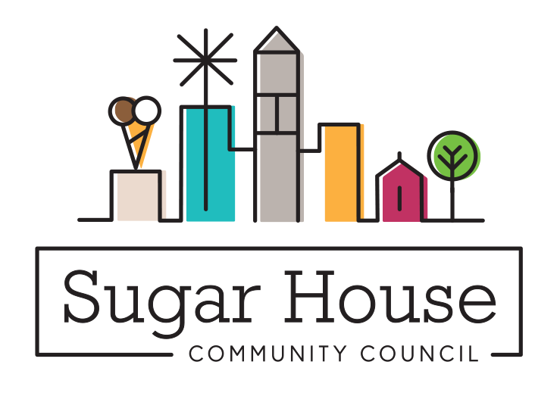

December 20, 2022

TO: Salt Lake City Planning Commission

From: Judi Short, Vice Chair and Land Use Chair
Sugar House Community Council

RE: PLNPCM2021-00190 Salt Lake City School District Signs Text Amendment

We have all seen the signs on the various schools around our city. What the school district recently learned was that none of these signs were legal as far as the Sign Zoning Ordinance. This is an attempt to amend the sign ordinance to incorporate existing signs, so they become legal, and to give guidance to schools, public and private, when designing new signs. We put this in our Sugar House Community Council December newsletter (circulation 2500), and on our website with a comment form for people to tell us what they think.

It was also on the SHCC LUZ agenda December 12. Sugar House Trustees and LUZ Committee members were notified (another 125) and we did not receive a single comment. Paul Schulte from the SLC School District attended our meeting, explained what they were trying to do, and answered a few questions. No one had any concerns.

We ask that you approve this amendment.

