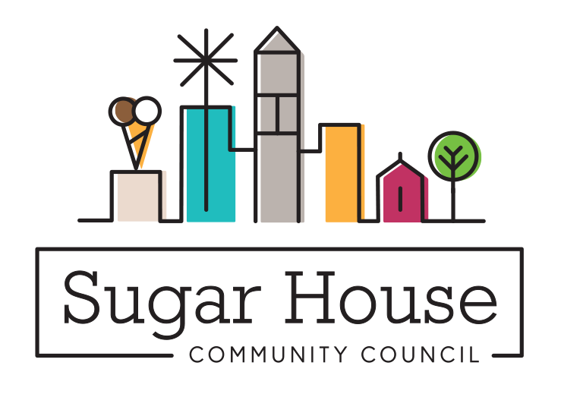

December 18, 2022

TO: Salt Lake City Planning Commission

FROM: Judi Short, First Vice Chair and Land Use Chair
Sugar House Community Council

RE: PLNPCM2022-00933– Conditional Use – _Holloran ADU - 2867 S Chadwick St

The main house is owned by a woman who is 90 years old. The purpose for the ADU is to have a place for her children or grandchildren to stay in when they visit her. They are removing the attached garage and rebuilding it with something that is up to code. The ADU is oriented to catch the sun in the winter or shade in the summer. The owner wants to re-do the landscape in a dry scape. The ADU is 650 sf, 1 bedroom, one office and the other room is a kitchen living space. There is 27% lot coverage, on a lot that is 8300 sf. There are three parking stalls on the property with two in the new garage and one on the driveway, plus a space on the street.

We did put flyers around the immediate neighbors, but did not receive any comments. This ADU meets all the requirements of the ordinance, and we ask that you approve it.

