Get to Know Your New SLC Airport
The New SLC provides passengers with an entirely new experience from curb to gate.
Nancy Volmer, SLCDA Communication and Marketing Director
Word count-693

It has been nearly a year since the Salt Lake City Department of Airports (SLCDA) turned the key and opened Phase 1 of The New SLC Airport. Early morning on Sept. 15, the lights dimmed on the original 1960s airport and brightened on a new parking garage, gateway center, terminal and Concourse A-west, where Delta Air Lines occupies 25 gates. Six weeks later—on Oct. 27—Concourse B-west opened with 21 gates for Alaska, American, Delta, Frontier, JetBlue, Southwest and United airlines.

A 990-ft. long tunnel—originally built in 2004—connects concourses A and B where passengers experience Utah’s four-season murals as they make their way through the passageway. Salt Lake City-based artist Tracy O’Very Covey painted summer and fall, while Texas-based artist Daas painted winter and spring.

“This day has been years in the making,” said SLCDA Executive Director Bill Wyatt, on opening day. “To say we are excited to be here today is an understatement. After six years of construction and many more years of planning, we are proud to open the first new U.S. hub airport in the 21st Century,” Wyatt added.

The need to build a new SLC airport became apparent as passenger numbers grew and facilities became outdated. Prior to the pandemic, SLC recorded more than 26 million passengers in 2019, in an airport that was built for 10 million passengers.

The advantages of building an entirely new airport is that architects were able to design for the future to create a more efficient and more sustainable facility. The new concourses were designed in a parallel configuration for today’s larger aircraft—compared to the previous pier layout built for smaller planes—which eliminates aircraft bottlenecks and idling, so airlines are able to get their planes to the gate and back in the air quicker.
SLCDA also built the new facilities with LEED Gold Certification from the U.S. Green Building Council as a goal. The airport will achieve this certification through a variety of ways, such as converting all airline ground service equipment to electric. Plus, the use of natural light also helps to achieve the airport’s energy goals.
With Phase I of The New SLC completed, demolition on the previous airport began immediately and took about eight months to tear down. Phase 2 construction is well underway and includes the build out of Concourse A to the east and construction of a permanent tunnel to transport passengers between concourses A and B. Phase 2 is planned for to open in 2023-2024 and planning is underway for Phase 3 and Phase 4.
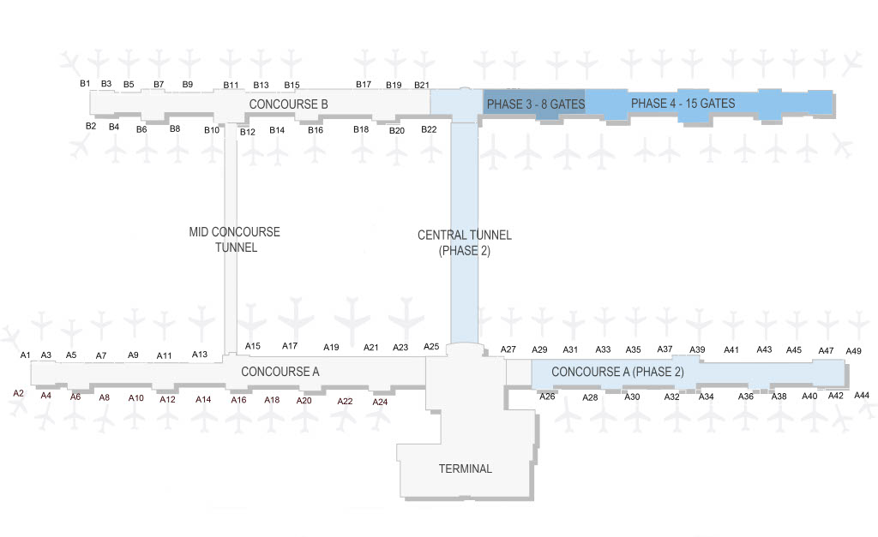
Additional highlights of The New SLC include:
- Large-scale art installations by artist Gordon Huether—The Canyon, The Falls, The Plates and Benches—that represent Utah’s natural beauty and provide a sense of place.
- A two-level roadway system with an elevated road designated for departures.
- A parking garage with 3,600 parking stalls and a camera-based sensor system that uses lights to indicate where open spots are located. Plus, 56 places to charge electronic vehicles.
- The Gateway, which houses car rental counters and quick-check airline ticket counters.
- 16 security screening lanes with automatic return bins to aid in touchless travel.
- 45 restaurants and shops—all with street pricing.
- Electronic plug-ins at each seat and in open seating areas throughout the airport.
- 7 miles of luggage conveyor belts to accommodate oversized bags, such as skis, snowboards, bike boxes and golf clubs.
- Aircraft gates that employ the SAFEGATE Aircraft Docking System to provide pilots active guidance to support safe, efficient and precise automated aircraft parking during all operating conditions.
- 31 restrooms (many with private lactation rooms), deep bathroom stalls and unique Whimsy Wall artwork. Passengers are never more than 150 feet away from the next restroom facility.
- The Greeting Room where friends, families and others can wait to pick up passengers.

To learn more about The New SLC, go to slcairport.com/thenewslc/ to find orientation videos and maps. In addition, a phone app is available via the App Store and Google Play.

