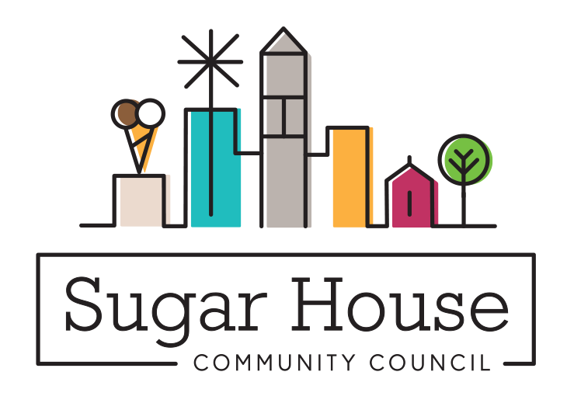
May 22, 2019

TO: Salt Lake City Planning Commission

FROM: Judi Short, Vice Chair and Land Use Chair
Sugar House Community Council

RE: PLNPCM2019-00264 Sugar Alley Conditional Building and Site Design Review

Thank you for the opportunity to review the mixed-use eight story building proposal at 2188 S Highland Drive. This building is being built on a key parcel in the Sugar House Business District, and will be very visible as people walk and drive down Highland Drive. We really like the Sugar Alley concept, a pedestrian corridor on the north side of this building, with all glass and a number of entrances out onto Sugar Alley. They intend for this to be a place open to the public, and hope that the businesses will take advantage and use some of the outside space for things like dining. This building is within easy walkable distance of the S-Line, Sugar House Park, and Fairmont Park. The glass atrium in the middle of the Highland Drive street front is to be public space, and the hope is that the retail spaces will spill over into that area.

The design of this building is very nice. The materials to be used are a nice mix of old and new ideas, and this will fit nicely into the neighborhood. There are lots of built in amenities for residents, and for customers of the retail, and for just people who are walking by, to stop and stay a while. The Sugar Alley should be a very inviting place, made more so because no cars will be allowed. We don’t object to doing away with the 15’ setback for this one section as it makes a nice difference in the overall design of this corner of the building and the view from Highland Drive.

There are to be 186 apartments Class A apartments (we are told more upscale than anything currently in the SHBD), with 70% studio and one-bedroom, and 30% two-bedroom units. We are increasingly receiving comments asking about three-bedroom apartments in Sugar House. People who live here like it, and if they have growing families, two bedrooms isn’t enough space. We would think it would be prudent to offer some three-bedroom units, perhaps even converting some of the units planned for this building into three-bedroom units. Even 10 units could make a difference.

We are also dismayed to see no affordable units in this building. Of some 1000 units approved in Sugar House, only 60 are affordable. Where are the folks who serve us, in the restaurants, and the stores supposed to live? They live in West Valley and drive their car in. Don’t know if they can make connections via TRAX to get here in a reasonable period of time.

Retail parking is at a premium in Sugar House. I know they have 286 spaces, but how much of that is to be for all the retail they are adding? If they have one space for every apartment, that leaves 100 for the retail. Before all the building began on the Granite Block, there were 75 parking spaces on this block, not counting the Habit Burger parking lot. This is clearly not a big gain for retail parking. In Sugar House, we have seen a number of small local businesses move out of the SHBD because they don’t have enough parking. All the spaces that used to be available seem to be taken up by employees of the retail, filled before the customers come in to shop. Without a serious improvement in the local bus service, we will continue to see the small businesses that were once what we loved about Sugar House leave, to find other places with more parking for customers. At least two restaurants have failed in the Granite or Rockwood Buildings because of lack of parking. We need a community solution, like a good parking app that identifies empty spaces and a willingness for people to put their spaces into the communal pool. Some would call that a Parking Authority. Maybe most of the inhabitants of this building will work in Sugar House, or bike to work, or take the TRAX, and one parking space will be all they need.

So, while we are pleased to see this glitzy new building in our neighborhood, we worry that there won’t be enough parking, that the fancy national retailers that will come to this space may usurp the small businesses and drive them away, and we can’t do anything about it. Land prices are ridiculous, no small business can afford the rent, and if we lose the long-term businesses, that cache is gone forever.

We look forward to working with the Lowe brothers, and other developers, on the way-finding sign package that will help make this spot and define the area. We appreciate very much the way they have worked with us for about a year to design this building and gather our feedback along the way. Nice to have developers that pay attention to what we think, and especially pay attention to and respect our Sugar House Master Plan. I think this needs to go to the Planning Commission, not just be approved by staff. They deserve to see something well designed, with community input.

Attachment: Comments from the Community

