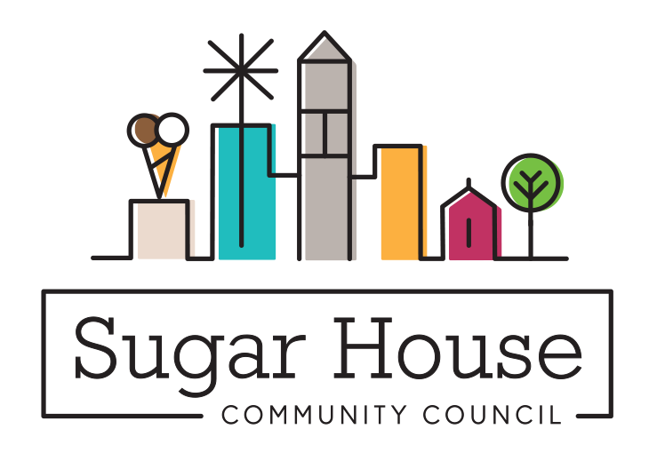

June 7, 2021

TO: Salt Lake City Planning Commission

FROM: Judi Short, Vice Chair and Land Use Chair
Sugar House Community Council

RE: PLMPCM 2019-00225 Child Day Care Amendments

The Sugar House Community Council reviewed this in December of 2019, at its Land Use and Zoning meeting.
The discussion centered around the fact that we all thought having more small day care opportunities would be a good thing for the residents of Salt Lake City. Having local, near home, day care would make it easier for working mothers to drop off and pick up the child without taking extra time to have to drive a long distance to a day care provider. And it would provide income for a stay at home parent to offer this service in a limited capacity.

We received no written comments. The few verbal comments we received had to do with noise, and it was mostly during the drop off or pick up timeframes, when a number of cars and number of children were entering and exiting. A recommendation was made to have some requirement to pay attention to the noise and think about how the neighbors might be affected, but no specific solutions were proposed.

We reviewed the purpose of this amendment and thought they were all worthwhile, we ask that you approve this
Text amendment.

