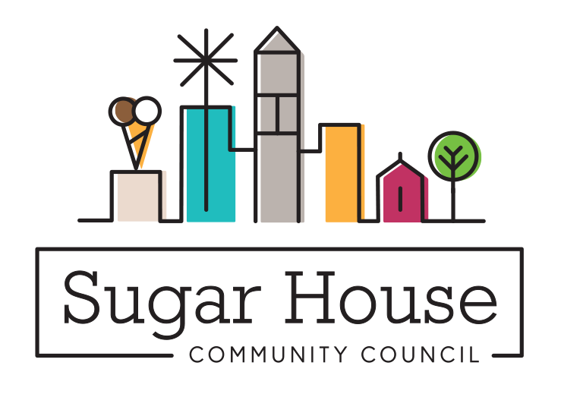

December 20, 2022

TO: Salt Lake City Planning Commission

From: Judi Short, Vice Chair and Land Use Chair
Sugar House Community Council

RE: PLNPCM2022-00802 2167 S 800 East Alley Vacation

This was posted in the Sugar House Community Council newsletter for December, and we discussed it at our January 9 Land Use and Zoning committee. We received no comments about this, and all the adjoining neighbors had already signed the application to close the alley. No one had any objections, and we wondered why this had not been closed many years ago. It is certainly not drivable.

We ask that you approve this alley closure.

